**“EQUITY ANALYSIS BY USING POWER BI”**

**INTRODUCTION**

In dynamic financial markets, the ability to make informed investment decisions is paramount. Integrating advanced analytics tools has become essential for financial professionals looking to gain a competitive advantage. Our focus this summer will be on using the power of Microsoft Power BI to enhance equity analysis.

Equity analysis is an analysis of the financial performance and growth potential of a company’s stock. Traditional methods often fail to provide a complete and transparent picture of complex financial issues. This internship project aims to fill this gap by leveraging the power of Power BI, a powerful business analytics tool.

This role provides an opportunity for interns to gain hands-on experience in equity analysis, data visualization and business intelligence. By the end of the internship, participants will have a comprehensive understanding of how to effectively use Power BI to make data-driven financial decisions.

Through this exercise, trainees will not only enhance their technical skills but also gain a strategic perspective in approaching equity analysis. The resulting insights and visualizations will not only help private investors but also be a valuable resource for financial professionals navigating today’s complex financial markets.

This internship project aims to equip participants with more relevant skills in finance, providing a solid foundation for future professional endeavours in the areas of investment analysis, investment advice, and decision a depending on the data

**OBJECTIVES**

1. To understand the limitations of traditional Excel-based equity analysis.
2. To explore the capabilities of Power BI in enhancing equity analysis.
3. To demonstrate the step-by-step transition from Excel to Power BI.

**POWER BI FEATURES FOR EQUITY ANALYSIS**

1. **What Is Equity Analysis?**

Equity analysis, also known as stock or share analysis, is a method of financial analysis that analyses the financial performance and financial strength of a company’s stock It analyses different aspects of the company to inform investment decisions. The purpose of equity analysis is to look at the intrinsic value of a stock and determine if it is overvalued, undervalued, or overvalued in the market

There are two basic approaches to equity analysis: fundamental analysis and technical analysis.

* Fundamental research:
* Financial Statements: The basic analysis involves a thorough examination of a company’s financials, including balance sheets, income statements and statements of cash flows This helps analysts understand a company’s financial health, profitability and cash as it continues to be under.
* Earnings and Dividends: Analysts examine the company’s earnings history and growth prospects. Dividend payouts and sustainability are also considered, as they can be indicators of the financial performance of the company.
* Management and Governance: The quality of management and corporate governance practices is examined to measure the effectiveness of leaders in managing the company and ensuring that transparency factors.
* Technical Analysis:
* Price and volume trends: Technical analysis focuses on historical price and volume data. Moving averages, Chart structures and other technical indicators are used to identify trends and potential entry and exit points for investors.
* Market sentiment: Analysts examine market sentiment, as reflected in stock price movements and trading volume. This approach assumes that historical price movements and trends can predict future outcomes.

1. **What Is Power Bi?**

Power BI is a business analytics tool developed by Microsoft that enables users to brainstorm and analyse data from multiple sources to make informed business decisions Provides user-friendly interfaces for creating reports and dashboards interactive and scalable, making it easier for organizations to search their information

Key features of Power BI include data connectivity, which allows users to connect to multiple databases, spreadsheets, cloud-based services, etc. It also enables data exchange, and allows users to users are able to clean, shape and model their data for better analysis.

Power BI helps create visually appealing interactive reports with its drag-and-drop interface. Users can create dynamic dashboards with charts, graphs, and other visualizations to better communicate trends, patterns, and insights in the data.

Furthermore, Power BI has teamwork tools that let users share and work together on dashboards and reports. Users always get the most recent information because it allows real-time data changes.

Power BI is part of the Microsoft Power Platform and seamlessly integrates with other Microsoft products and services to deliver complete solutions for data analytics and business intelligence It caters to a wide range of users from business analysts to data scientists, making it a versatile tool for organizations of all sizes.

1. **Power BI Features for Equity Analysis:**

3.1 Dynamic dashboards:

Power BI’s dynamic dashboards are revolutionizing the visualization of equity analytics by providing interactive and real-time insights. Dynamic dashboards are characterized by:

* Interactivity: Users can interact with visual elements such as charts and diagrams, enabling precision data dynamic analysis. This interaction enhances the user experience and accelerates decision making.
* Real-time updates: Power BI dashboards can be configured to pull in real-time data, ensuring that the information displayed is always current. This feature is important in the fast-paced world of equity research, where timely information is paramount.
* Customization: Users can customize the dashboard based on their specific needs. This includes the ability to add or remove visual elements, apply filters, and focus on key performance indicators related to equity analysis.

3.1.2 Implementation:

Creating dynamic dashboards in Power BI requires the following steps.

* Data import: Import equity data into Power BI from a variety of sources, including Excel, databases, or external APIs.
* Data visualization: Use Power BI’s extensive library of visualization tools to create complex charts, graphs, and tables.
* Dashboard creation: Combine individual ideas into a cohesive dashboard. Organize content for optimal user experience and interaction.
* Communication Structure: Describe the relationship between different visual elements. For example, related charts in the dashboard can be updated dynamically by clicking on a specific data point in a chart.

3.2 Advanced Data Modelling:

Power BI’s advanced data modelling capabilities empower equity analysts to create sophisticated models that capture complex financial relationships. Key features include:

* Relationships: Establish relationships between data tables, to allow for easy integration and analysis of interrelated financial ratios.
* Time intelligence: Power BI delivers primarily time-based activity and statistics, facilitating in-depth analysis of historical equity data and trends.

3.2.2 Implementation:

Advanced data modelling for use in Power BI includes the following:

* Data import and transformation: Import the raw equity data and apply the necessary transformations to prepare it for modelling.
* Establishing Relationships: Define relationships between related tables based on common keys or fields.
* Time intelligent integration: Use time intelligent functions to analyse precision data across time periods.

3.3 Connection to external data sources:

Power BI’s seamless integration with external data sources increases the depth and breadth of accuracy analysis. This feature includes:

* Connection options: Power BI supports direct connections to data sources, including databases, cloud services, and APIs. This ensures that equity analysts can access a variety of data for comprehensive analysis.
* Real-time data refresh: Configure automatic refresh options to keep equity analysis data up to date. This is especially valuable when dealing with dynamic market conditions and changing economic data.
* API Integration: Power BI allows integration with external APIs, enabling analysts to pull in real-time market data, financial reports, and other relevant information to enhance their equity analysis

3.3.2 Implementation:

External data sources to be included in Power BI include the following:

* Connectivity plan: Establish connections to external data sources, such as databases, cloud platforms, or web services.
* Data Import Configuration: Configure Power BI to import data from external sources, ensuring that the required fields and parameters are defined correctly.
* Automatic refresh schedule: Set automatic refresh schedule to keep equity analysis data current.
* API Integration: Leverage Power BI's ability to integrate with external APIs, providing real-time continuous feedback into the accuracy analytics model.

In conclusion, Power BI’s features for equity analysis including dynamic dashboards, advanced data modelling, and integration with external data sources empower analysts to create insightful, interactive, and updated analysis, traditional Excel- based approach.

1. **Transitioning from Excel to Power BI:**
   1. Importing Excel Data into Power BI:

The transition from Excel to Power BI starts with the import of existing equity data. Power BI simplifies the simple process of importing Excel data:

* Data Source Selection: Go to the "Home" tab of Power BI and select the appropriate data source. Select "Get Data" and then "Excel" to start the import process.
* Workbook selection: Specify a location and select an Excel workbook that contains equity data. Power BI provides options to import all pages or to select specific tables and ranges.
* Data Preview: Power BI provides a preview of the data, allowing users to view and select specific tables or sheets for import. This step ensures that only relevant data is imported into the Power BI environment.
* Data Load: After selecting the desired data, click "Load" to load the Excel data into Power BI. Power BI automatically creates data structures based on the input data, laying the foundation for subsequent analysis.
  1. Amendments and Corrections:

Once you import Excel data into Power BI, the next important steps are data transformation and cleaning to ensure data accuracy and relevance:

* Query Editor Access: Power BI provides a Query Editor tool used for data. Go to the "Home" tab and select "Transform Data" to access this tool.
* Data cleaning: Use the Query Editor to cleanse and modify data by removing duplicates, handling missing values, and fixing any inconsistencies. Power BI’s intuitive interface simplifies tasks such as labelling, converting data types, and using formulas.
* Advanced transformation: Take advantage of the advanced transformation options available in Power BI, including using conditional spreadsheets, custom formulas, and big data processing using the M language. Those features this increases your ability to tailor data to specific equity analysis needs.
* After data load transformation: Once the transformation is complete, click "Close & Apply" in the query editor to save the transformation and load the cleaned data into Power BI for analysis

4.3 Developing interactive dashboards:

The power of Power BI lies in its ability to create dynamic and interactive dashboards far beyond the capabilities of static Excel spreadsheets:

* Visualization tools: Use Power BI's extensive library of visualization tools, including charts, graphs, and tables, to visually represent equity data
* Drag-and-Drop Interface: The user-friendly Power BI interface allows users to drag and drop visuals onto the canvas, facilitating the creation of custom dashboards
* Slicers and Filters: Slicers and filters have been implemented so that users can interact with the data dynamically. This factor is important for analysing various equity analysis metrics, such as industry, time, or economic metrics.
* Dashboard Layout: Arrange images on the dashboard canvas to create a unified and intuitive user experience. Power BI provides options for resizing, organizing, and organizing content for maximum impact.
* Link Settings: Define links between visual elements to ensure graphs associated with the dashboard are updated dynamically by selecting data points in a single graph

4.3.2 Implementation:

Creating interactive dashboards in Power BI involves the following steps.

* Data Analysis: Understand the structure and content of imported and transformed data using the Data view in Power BI.
* Selection of visual aids: Choose appropriate visual aids (charts, tables, maps) based on the nature of the equity analysis and the insight you want to impart.
* Drag-and-Drop: Drag relevant fields and view elements to create basic views. Power BI’s intuitive interface allows for easy integration.
* Slicer and filter settings: Add slicers and filters to allow users to interact with data dynamically.
* Dashboard Layout: Arrange and organize visual elements on the dashboard canvas to create an attractive and informative layout.
* Interactive Design: Define connections between visual elements to create a seamless and interactive experience.

By converting from Excel to Power BI and following these steps for importing, editing, and creating interactive dashboards, equity analysts can leverage the full power of Power BI, gaining deeper insights, for their equity the overall performance of the research program has improved. to improve efficiency

**CASE STUDY: APPLICATION OF POWER BI IN EQUITY ANALYSIS:**

**AIM:**

To Present Reports in Data Form Using Power Bi Tool for Pictorial/Graphical Representation of Data and Portfolio of Investor

**TASK PERFORMED:**

1. Collect Data from Fundamental and Technical Analysis
2. Get The Microsoft Power Bi Application
3. Paste Data in Power Bi Blank Table
4. Use Visualization Tool for Data Presentation
5. Create Graphical Presentation Using Data

**DATA REPRESENTATION:**

**TASK 1:**

* Select Three Sectors for Investment Like FMCG, IT, BANKS etc.
* After Selecting Sector Find The 3 Stocks of Each Sector:
* FMCG: DABUR, MARICO, ITC.
* IT: TCS, WIPRO, INFOSYS.
* BANKS: SBI, FEDERAL, HDFC.
* Allocate The Investment in Each Sector.

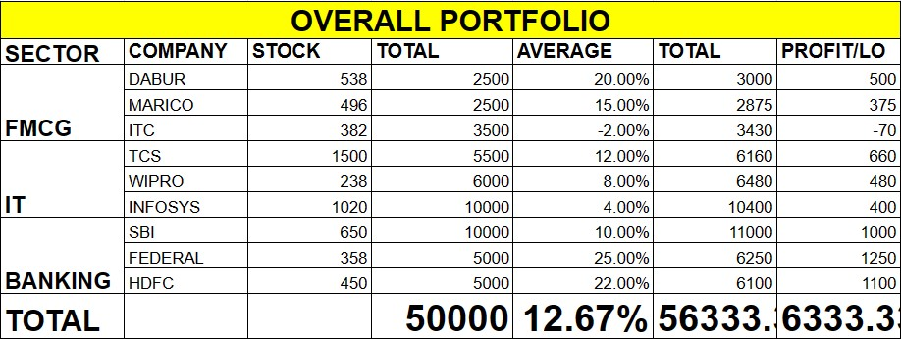

**TASK 2:**

* The Fundamental Factors of All Stocks.

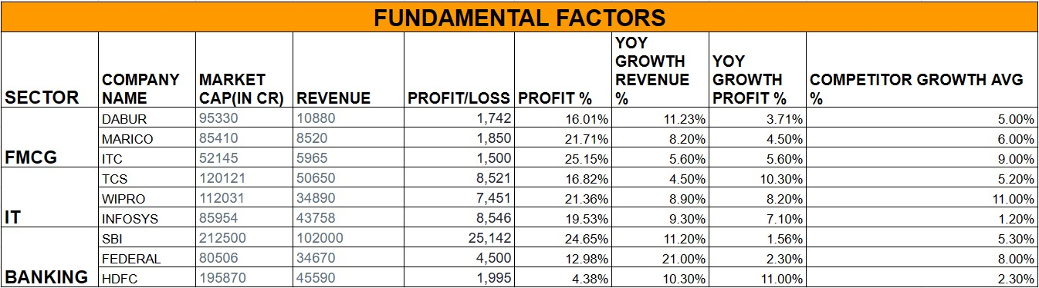

**TASK 3:**

* The Technical Factors of All Stocks.

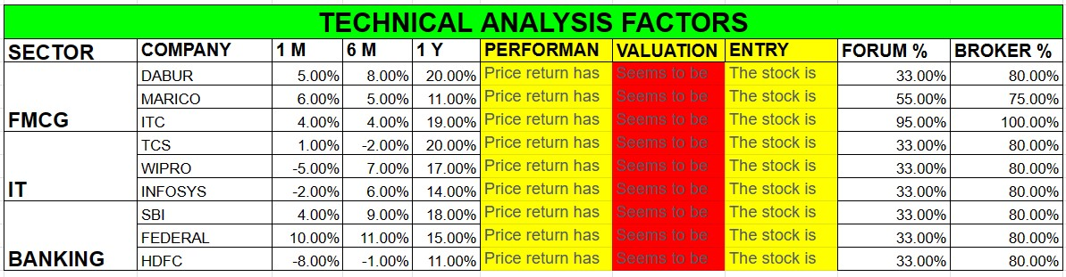

**TASK 4:**

Paste Data in Power Bi Blank Table



**TASK 5:**

Use Visualization Tool for Data Presentation:

* **Pie Chart** for Sum of Total Investment by Company Name:

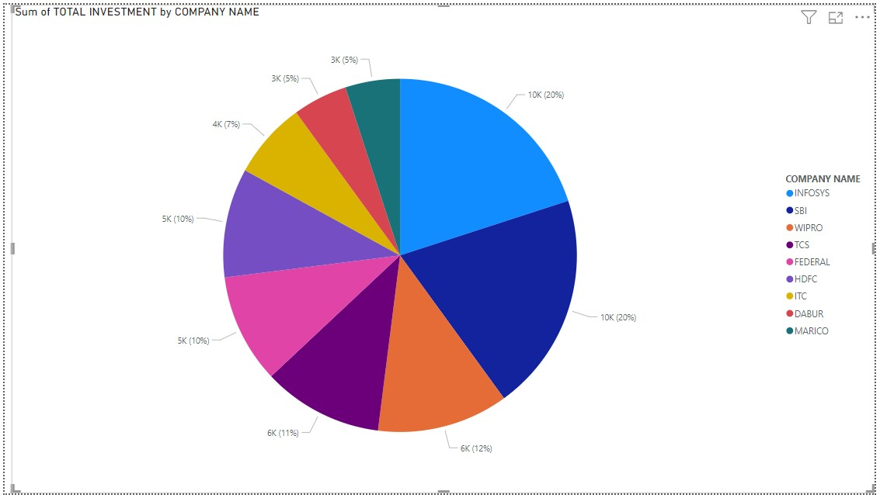

* **Daunt Chart** for Sum of Total Portfolio by Company Name:

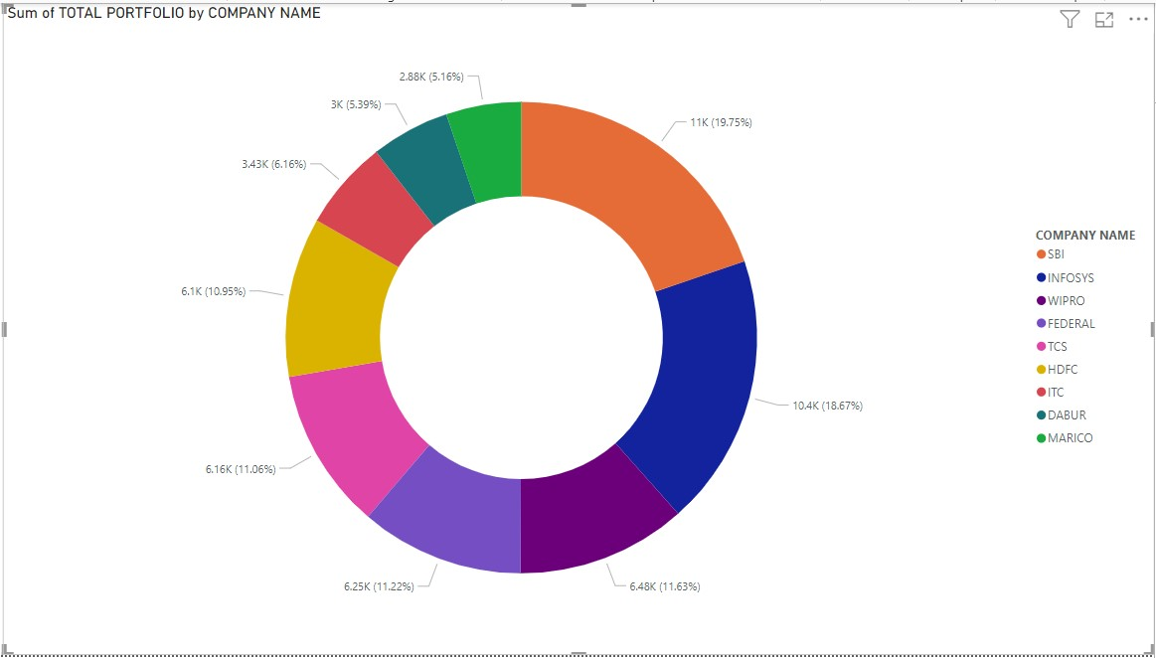

* **Gauge For** Sum of Profit/Loss:

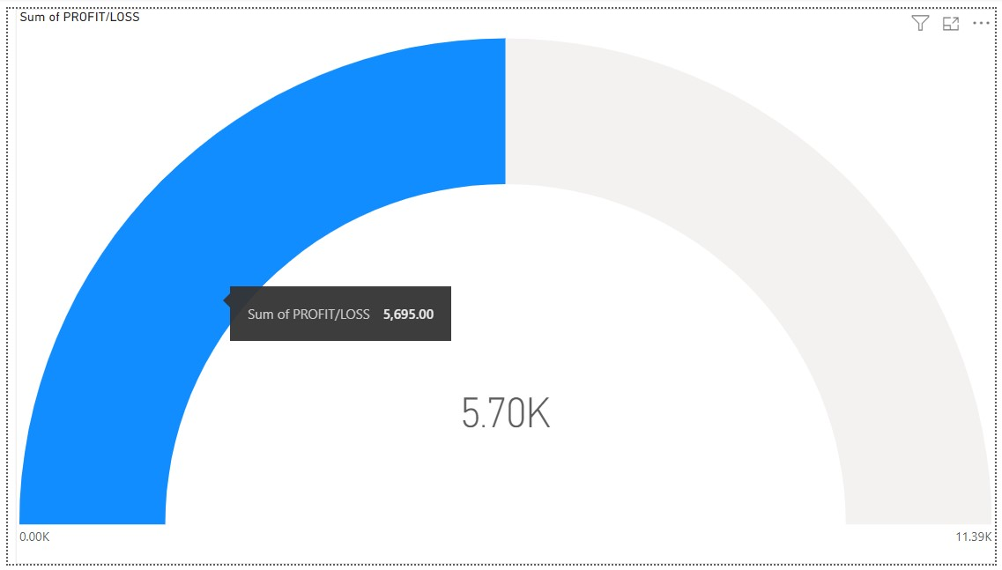

**TASK 5:**

Create Graphical Presentation Using Data

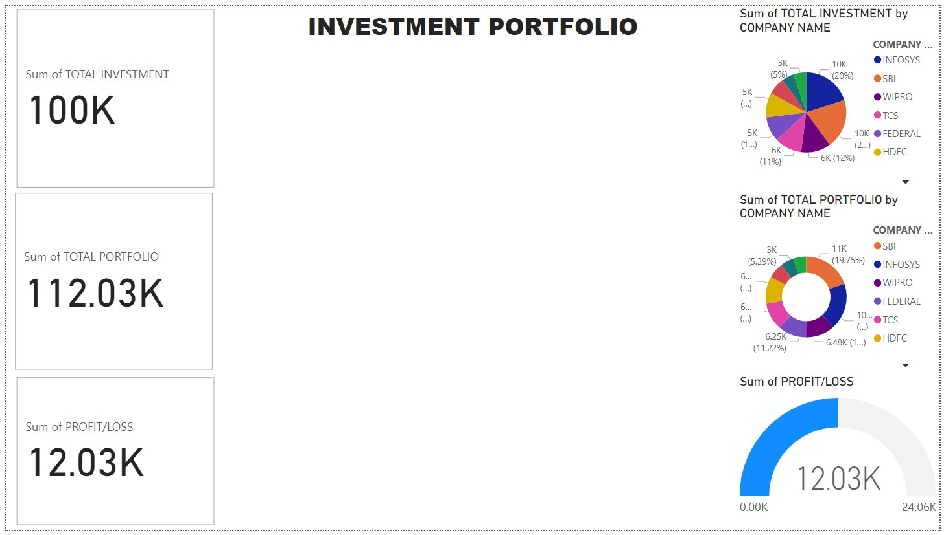

* By using slicer

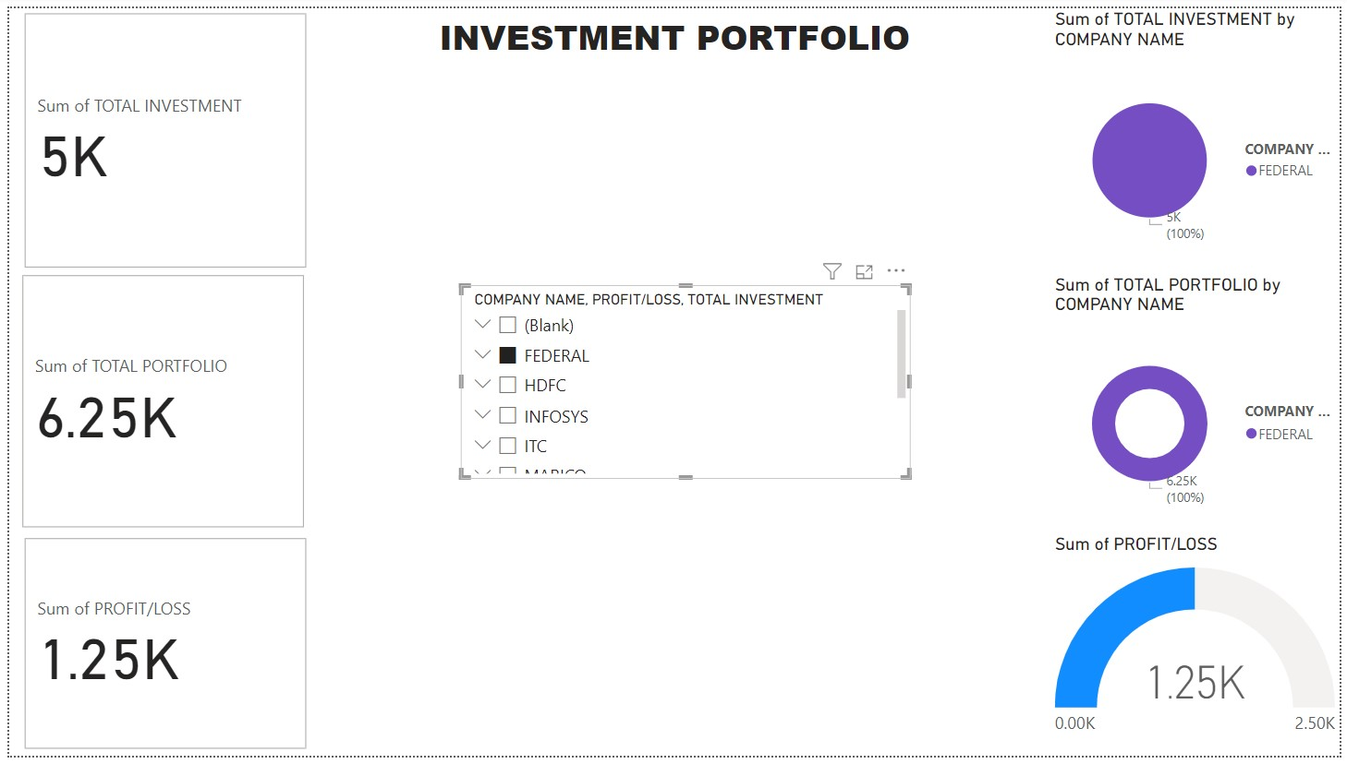

**CONCLUSIONS:**

Power BI is a helpful tool for stock market investing because it can convert complex data into easy-to-understand charts and graphs. It helps you track and analyse banking data, making it easier to make informed financial decisions. Power BI, you can see trends, patterns, and important data about your investments, which can help you make smarter choices and you can make more money in the stock market. It’s like having a clear map that guides you through the sometimes-confusing world of stock investing.